Maintenance
This chapter provides personnel with instructions on actions required for maintaining or restoring functionality of the machine.

Adhering to regulations Disposal of materials
Dispose of materials removed from the machine in accordance with
the instructions and directives applicable at the installation location.

Disconnecting and securing
This section provides personnel with instructions on setting the machine to the Deenergized machine operating status.
The activities to be performed comprise the following:
- Completely disconnect the machine from the power sources.
- Discharge residual energy.
- Secure the machine to prevent it from being restarted.
- Check the effectiveness of the energy isolation.
WARNING!
Servicing unsecured shut-off elements
Shut-off elements are used for energy isolation and to secure devices to prevent them from being restarted. Shut-off elements themselves are not disconnected from power sources. There is therefore a risk of injury when servicing shut-off elements.
This could result in death or serious injury.
– Before servicing a shut-off element, interrupt the operator's media supply.

General procedure
Personnel:  Maintenance personnel

- Preparation
Identify any power sources affected and any hazards that are caused by you.
Locate shut-off elements.
Prepare material to secure each shut-off element.

- Informing
Inform all persons involved about the shut-off and the corre‐ sponding measures.
- Isolation
Switch off the energy supplies in the specified order, see section

“Work steps for disconnecting and securing”.
- Finalizing
Secure shut-off elements against an unintentional restart using the equipment intended for this purpose.
Label shut-off elements with labels that display a warning about unintentional restarts.
- Checking
Ensure that the shut-off elements have been shut off properly and are secured against restarting unintentionally.
Ensure that any residual energy has been discharged.
- Maintenance and repair
Ensure that maintenance work is performed only by trained per‐ sonnel.
Pay attention to residual energy and protect against residual risks.
Perform maintenance work.
If individual power sources are required to check maintenance work, carry out the "Restart" step for this energy source.
- Restarting
Ensure that all maintenance tasks have been completed.
Inform all persons involved before energy supplies are switched on.
Observe labels, remove labels and shut-off equipment.
Switch on the power supplies in the specified order; see section

“Work steps for switching the machine on again”.

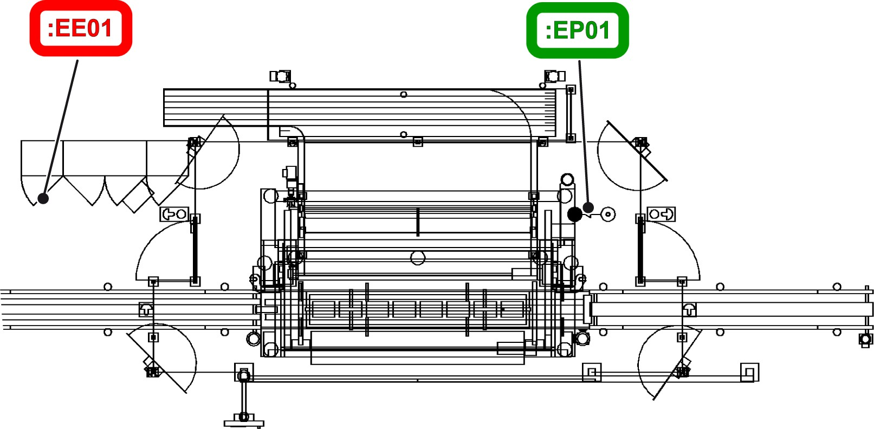

Figure 91: Overview of the shut-off elements on the machine


Electrical energy Pneumatic energy

Introductory work steps
For planned servicing work, carry out the preliminary steps listed below. Perform all realizable actions in the event of a fault. Evaluate residual risks and initiate protective measures.

1. | End production: see operating manual, chapter “Operation”, section “Production”.
Work steps for disconnecting and securing
Before beginning maintenance work, switch off the power supplies according to the following work steps.
 | Power source | Shut-off element | Action | Check
2. | Potential energy in the cross con‐ veyor and the lifting frame con‐ trol. | Operator console | Move the machine cross conveyor and the lifting frame control into the lowest position using manual functions. | When the assem‐ blies are in the lowest position, the level of risk posed by potential energy is at its lowest.
2. |  | Operator console | The synchronous belt will continue to be ten‐ sioned in the lowest position. | Work on the syn‐ chronous belt may only be carried out by KHS personnel.

 | Power source | Shut-off element | Action | Check
3. | Electrical power, main energy | Main switch on the switch cabinet   | Turn the main switch to position [0]. Use a pad‐ lock to secure against accidental restarting and attach an information sign to the machine to indicate ongoing work.  Residual voltage may occur on motors and capacitors.  Before working on motors and capacitors wait 5 minutes to allow residual voltage to dissi‐ pate. Earth components. | All indicators on  the operator console have gone out.  All light signals on sensors have gone out.  The operational status lamp has gone out.
3. | Electrical power, main energy |  | All drives in the machine area and the braking resistor on the switch cabinet reach high tem‐ peratures during opera‐ tion. | Let all drives and braking resistors cool to below 55°C.  Test with a laser thermometer or other contactless heat measuring instrument.
4. |   Thermal energy | No shut-off ele‐ ment | Let all drives and braking resistors cool to a temperature below 55°C. | Test with a laser thermometer or other contactless heat measuring instrument.
5. | Pneumatics, compressed air supply to the entire machine | Main valve   | Close the main valve on the maintenance unit.  Secure the main valve in a closed position using a padlock to prevent it from being switched on again.  Attach an information sign to the machine for ongoing work. | Open the drain plug on the manual con‐ densate drain. The noise of escaping pressure should not be audible.

 | Power source | Shut-off element | Action | Check
6. | Integrated com‐ ponents | - | The integrated compo‐ nents on the machine contain energy. | To disconnect and secure the energy in the integrated com‐ ponents, see the separate instruction manual for the inte‐ grated components.
7. | Processed product residue | - | The processed product residue poses a risk  to all activities in the secured area. | Clean the secured area and remove all processed product residue.
Once the work steps for disconnecting and securing have been car‐ ried out, the machine is disconnected from all power sources.
Before carrying out any maintenance work, confirm that the power has been successfully isolated.

Work steps for switching the machine on again
Upon completion of maintenance work, switch on the power supplies according to the following work steps.
8. | Prepare the machine for operation, see operating instructions, chapter “Operation”, section “Preparing for operation”.
9. | Prepare for production; see operating instructions chapter “Operation”, section “Pro‐ duction”.
10. | Start production; see operating instructions chapter “Operation”, section “Production”.

Servicing
This chapter provides personnel with instructions on preventative actions for reducing wear and maintaining the functionality of the machine.

    - Safety instructions
DANGER!
Restart after maintenance and repair work
There is a danger of fatal injury from non-approved restart.
This could lead to severe or even fatal injury.
- Ensure that all work is completely finished.
- Enure the operational safety of the machine.
- Restart the machine only after obtaining approval from the person in charge.
- Before restarting, ensure that there is no one in the vicinity of the machine. Give a startup signal.
DANGER!
Falling materials
The materials to be processed may fall at any time. Risk of cuts from flying splinters and materials, or splinters and materials left lying around.
This could lead to severe or even fatal injury. – Shut down the machine and prevent it from
restarting before entering the safety area.
- Allow the machine to run empty before starting work in the machine area.
- Regularly remove residues of material for pro‐ cessing and fragments from the whole machine area.
- Do not remain in the immediate vicinity of materials to be processed.
- Wear safety goggles in the machine area.

WARNING!
Unauthorized machine startup
This could cause severe and even fatal injury.
- End production and stop the machine before car‐ rying out any work on the machine.
- Use your own padlock to secure the main switch against unauthorized startup.
- Secure and depressurize pneumatic components:
  - Switch off the control voltage for activating sole‐ noid valves.
  - Also, shut off the main air supply and depressu‐ rize the system.
  - Secure the air supply against unauthorized use with a padlock.
WARNING!
Accidental starting of the machine
Danger of being drawn in by moving machine parts! Danger of crushed limbs and lacerations! This could result in death or serious injury.
- Turn off the drive before carrying out any work on the machine.
- Turn off all necessary switches
- Use your own padlock to secure the main switch
at the electrical switch cabinet against unauthorized startup.
Each operator must secure the machine against inadvertent startup with his/her own padlock. This is particularly when several operators work on the machine.
- As far as possible, all work must be performed with the machine secured and deenergized.

WARNING!
Environmental pollution resulting from improper dis‐ posal
There is a risk of polluting the environment if operating materials such as lubricants and detergents are not disposed of properly.
- Follow the instructions in the leaflets enclosed with the operating materials.
- Collect used operating materials in suitable con‐ tainers marked in accordance with regulations.
- Dispose of contaminated cleaning utensils in suit‐ able containers marked in accordance with regula‐ tions.
- Observe local disposal regulations.
WARNING!
Pressurized system
Danger of injury from flying components and flowing media when opening pressurized components, tanks, and pipes.
This could cause severe and even fatal injury. – Before working on the system, depressurize
(relieve the pressure) and drain the system and
components.
WARNING!
Harmful cleaning media
Inhaling, swallowing, and exposing the skin or eyes to cleaning media and detergents may damage the skin, eyes, and respiratory tract or cause poisoning.
Please note the following when carrying out cleaning work:
- Always wear safety gloves and safety goggles.
- Do not eat, drink, or smoke.
- Make sure that there is adequate ventilation.
- Exercise extreme caution when handling deter‐ gents.
- Adhere to the instructions provided by the manufac‐ turer of the cleaning media and disinfectants.


NOTICE!
Non-qualified personnel
May result in damage to the machine or the sur‐ rounding area.
– Only qualified personnel should perform work on the machine.
NOTICE!
Use original parts from KHS
Original parts not supplied from KHS are not tested and approved. KHS will not be held liable for any damage resulting from the use of non-original parts.
– Only use original parts from KHS
NOTICE!
Failure to adhere to maintenance intervals Risk of machine damage
This could possibly lead to high repair costs and long machine downtime.
- Carry out maintenance work within the specified intervals.
- Carry out the maintenance work of one interval in addition to and independent of the maintenance work of other intervals.
NOTICE!
Improper cleaning of electrical equipment Risk of machine damage
- Never spray electrical equipment, switch or oper‐ ator panels, switch and control cabinets etc. with water.
- Never spray light barriers, inductive proximity switches, or sensors and ultrasonic sensors with water.
NOTICE!
Damage to components
Failure to replace wear parts at the times specified in the spare parts list leads to machine damage.
Replace wear parts at the times specified in the spare parts list.

NOTICE!
Wrong lubricant
Selecting the wrong lubricant causes damage to machine components.
– Use only the lubricants as indicated in the lubrica‐ tion plan.
NOTICE!
Damage caused by failure to rectify faults
Failure to rectify faults leads to machine damage.
Rectify any detected faults on the machine immedi‐ ately.
NOTICE!
Mixing lubricants
Mixing different types of lubricant or lubricants from different manufactures could lead to a loss of lubricity and cause chemical reactions.
This could cause product flaws, operational downtime, and damage or destruction of components.
– Never mix lubricants of different types or from dif‐ ferent manufacturers. In particular, never mix min‐ eral oil-based and synthetic lubricants.
NOTICE!
Using non-original manufacturer parts
Replacing components with non-original manufacturer parts during maintenance.
The result is misuse with regard to the intended use. This could lead to product flaws, loss of safety func‐ tions, and damage or destruction of components.
– Replace parts only with original spare parts from KHS.

    - Notes on servicing practices

Intervals
The time specifications for maintenance and lubrication are intervals.
The maintenance personnel must perform tasks with shorter intervals at each of the longer intervals.
For example, when carrying out tasks with an interval of 7000 operating hours, maintenance per‐ sonnel must also carry out tasks with an interval of 3500 operating hours.
Identification of lubricants
The lubricants specified in the maintenance instruc‐ tions are marked with lubricant symbols. See chapter, “Technical Data”, section “Maintenance” for informa‐ tion on lubricant symbols.

    - Servicing schedule
The maintenance work schedule is sorted by operating status and operating mode. The operating statuses and operating modes are described in the “Operating statuses and operating modes” section of the “Safety” chapter.

Operating status On Establishing machine status
Personnel:  Maintenance personnel
Prerequisites:
        - Personnel have been informed of the upcoming work on the machine.
        - No material for processing is supplied to the machine while work is in progress.
- Ensure that there is nobody in the secured area.
- Prepare the machine for operation, see chapter “Operation”, section “Preparing for operation”.
- Switch the [Operating mode] key switch to the [Automatic] posi‐ tion.
- In the “Type” menu, check that the relevant type has been selected and adjust as necessary.
- Activate the required functions in the “Programs” menu.
- Activate the “Production” program.
- Press the [Start] button.
  - The operator console displays a message stating that there is a lack of materials for processing.

Interval: Daily/every 24 operating hours
Place | Maintenance work | Personnel
Machine  - Fall guard  - Visual check of the emergency stop switches  - Functional test of the safety doors | - Check that the safety equipment is in proper working order; see section “Checking the functionality of the safety equipment” .  - Perform the visual inspection of the emergency stop switches for broken cables and tampering. | Maintenance personnel
Operator console | Check the functionality of the signaling equipment; see section “Checking the functionality of signaling equipment”. | Operating personnel
Machine  - Servicing unit | Set the working pressure to at least 5 bar, maximum to 6 bar; see section “Checking the servicing unit” . | Maintenance personnel
Container conveyor  - Flat top chains | - From outside the housing, move the flat top chain on the conveyors using the manual functions and check for visible damage. | Operating personnel
Pack conveyor  - Flat top chains | - From outside the housing, move the flat top chain on the conveyors using the manual functions and check for visible damage. | Operating personnel

Interval: Weekly/every 125 operating hours
Place | Maintenance work | Personnel
Machine | Check that the safety equipment is in proper working order; see section “Checking the functionality of safety equipment” . | Maintenance personnel
- Functional test of the depressu‐ rization
system
- Functional test of the emer‐ gency stop switches

Interval: Monthly/every 500 operating hours
Place | Maintenance work | Personnel
Machine  - Pneumatic lines  - Pneumatic con‐ nections  - Valve clusters | From outside the housing, conduct an acoustic check on all pneumatic lines, pneumatic connections and valve clusters to check for leaks. | Maintenance personnel
Machine frame  - Rollers  - Guide rails | - Move the cross conveyor (complete) with the manual functions.  - Perform a check from outside the housing of whether the movement causes any unusual noises when the rollers are rolled up on the guide rails. | Operating personnel
Cross conveyor (complete)  - Rollers  - Guide rails | - Move the gripper head carrier with the manual functions.  - Perform a check from outside the housing of whether the movement causes any unusual noises when the rollers are rolled up on the guide rails. | Operating personnel

Operating status OFF Generating a machine status
Personnel:  Operating personnel
        - Maintenance personnel
Prerequisites:
- Personnel have been informed of the upcoming work on the machine.
- No material for processing is supplied to the machine while work is in progress.
- Ensure that there is nobody in the secured area.
- Prepare the machine for operation, see chapter “Preparing the machine for operation”.
- Switch the [Operating mode] key switch to the [Automatic] posi‐ tion.
- Move the cross conveyor (complete) into the lower position with the manual function.
- Turn the [Control voltage] key switch to the [OFF] position.
  - It is not possible to start the machine or to move compo‐ nents.

Interval: Daily/every 24 operating hours
Place | Maintenance work | Personnel
Machine | - Check whether the LED display on all electrical sensors illuminates.  - Check the sensor alignment. | Operating personnel
Machine  - Machine frame | - In operating status [On], move the cross conveyor (complete) into the lowest position using the manual func‐ tions.  - Switch the machine to operating status  [Off].  - Once the machine is in operating status [Off], enter the secured area and check the synchronous belts on the frame for visible damage. | Operating personnel

Interval: Weekly/every 125 operating hours
Place | Maintenance work | Personnel
Machine  - Hazard signs | Check that signs are complete, undam‐ aged, legible and securely positioned. | Operating personnel
Machine  - Housing  - Safety doors  - Protection shields  - Concave mirror | - Apply gentle force to test the safety equipment for stability.  - Visually inspect the safety equipment for tampering. | Operating personnel

De-energized machine Generating a machine status
Personnel:  Operating personnel
        - Maintenance personnel
Personnel have been informed of the upcoming work on the machine.
Perform measures for power isolation; see section “Isolating and securing”.

Interval: Daily/every 24 operating hours
Place | Maintenance work | Personnel
Machine | - Remove any residue of material for processing.  - Remove any foreign objects.  - Clean the rubberized surfaces.  - Clean all light barriers and reflectors with a cloth. Do not spray the light bar‐ riers, light sensors or the electronic and visual devices. | Operating personnel
Synchronous belts on the cross con‐ veyor (complete) | Check the synchronous belts for visible signs of damage. | Operating personnel
Gripper head  - Gripper | - Check the grippers for visible signs of damage.  - Clean the grippers with a cloth.  - Have any damaged grippers replaced by maintenance personnel. | Operating personnel
Container table  - Switching flags | - Check the switching flags for visible signs of damage.  - Have any damaged switching flags replaced by maintenance personnel. | Operating personnel

Interval: Weekly/every 125 operating hours
Place | Maintenance work | Personnel
Servicing unit | - Check the water separator on the serv‐ icing unit.  - Drain water if necessary by opening the valve. | Operating personnel
Container conveyor  - Pushover plates | - Check the pushover plates for visible signs of damage.  - Have any damaged pushover plates replaced by maintenance personnel. | Operating personnel

Interval: Monthly/every 500 operating hours
Place | Maintenance work | Personnel
Machine  - Lubrication lines  - Lubrication con‐ nections  - Lubricant distrib‐ utor | - Check all lubrication lines, lubrication connections and lubricant distributors for leaks and damage.  - Remove any excess lubricant. | Maintenance personnel
Switch cabinet | - Check that all fans are in proper working order.  - Clean all fans and filter mats. | Maintenance personnel
Machine | - Check all surfaces and all drag chains for damage.  - Check that all screw connections on moving and load-bearing parts are secure.  - Check visible electrical lines, con‐ nections and distributors for visible damage. | Maintenance personnel
Machine  - Rollers  - Guide rails | - Check the rollers for visible damage.  - Check the guide rails for visible damage. | Operating personnel
Cross conveyor (complete)  - Rollers  - Guide rails | - Check the rollers for visible damage.  - Check the guide rails for visible damage. | Operating personnel
Operator console | Check the connections and the operator console for damage. | Operating personnel

Interval: Annually/every 7000 operating hours
Place | Maintenance work | Personnel
Machine | Change the synchronous belt on the frame of the machine. | KHS personnel
Lifting frame control | Replace all synchronous belts. | KHS personnel

Interval: Every four years/every 28,000 operating hours
Place | Maintenance work | Personnel
Machine  - Frame | Change the guide rails. | KHS personnel
Machine | Replace all bearings and circlips. | KHS personnel
Machine  - Cross conveyor (complete) | Replace all synchronous belts. | KHS personnel

Check that the safety equipment is functioning correctly
To guarantee safety, the safety equipment must be checked for func‐ tionality regularly in accordance with the maintenance schedule.

Checking the functionality of the emergency stop switches Personnel:  Maintenance personnel
Prerequisite:
- The machine is in operating state “On”, see section “Servicing schedule”.
- Ensure that no one is in the danger area.
- Press the [Emergency stop switch].
  - The signaling equipment indicates a fault. The machine is stopped. On the machine overview screen, the operator con‐ sole indicates which [emergency stop switch] was pressed.
- Check that the information in the message matches the trig‐ gered [emergency stop switch].
- Press the [Start] button on the control panel for the machine.
  - The machine should not start because it cannot be started with a depressed [emergency stop switch].
- Unlock the [emergency stop button].
  - The signaling equipment no longer indicates a fault. The machine does not automatically begin to move.
- Check all of the [emergency stop switches] shown in the “elec‐ trical circuit diagram” independently of one another.

Checking the functionality of the safety doors Personnel:  Maintenance personnel
Prerequisite:
The machine is in “On” operating mode; see section “Servicing schedule”.
- Open a safety door manually; see chapter “Safety”, section

“Safety equipment”.
  - The signaling equipment indicates a fault. The machine is stopped. On the machine overview screen, the operator con‐ sole indicates which safety door is open.
- Check that the information in the message matches the opened safety door.
- Press the [Start] button on the control panel for the machine.
  - The machine should not start because it cannot be started with an open safety door.

- Close the safety door, see chapter “Safety”, section “Safety equipment”. Reset the pending message on the actuation housing of the [safety door].
  - The signaling equipment does not indicate a fault. The machine does not automatically begin to move.
- Check all of the safety doors shown in the “project plan” inde‐ pendently of one another.

Checking that the fall guard is functioning correctly Personnel:  Maintenance personnel
Prerequisite:
The machine is in “On” operating mode; see section “Servicing schedule”.
- Turn the [Control voltage] key switch to the [OFF] position.
  - The depressurization system opens and releases the pneu‐ matic pressure in the clamping element of the fall guard.
- Enter the secured area and visually inspect the fall guard for any signs of tampering.
- Check that the clamping element has been closed correctly, by manually checking that the guide rods have been sufficiently rotated.
- On the operator console, check that there are no fault messages indicating that a clamping element has not been closed.
  - Close the clamping element as indicated, and secure the lifting frame against falling.
- Turn the [Control voltage] key switch to the [ON] position and acknowledge any messages.
- On the operator console, check that there are no fault messages indicating that a clamping element has not been opened.
  - Open the clamping element as indicated and release the movement of the lifting frame.

Checking the functionality of the depressurization system Personnel:  Maintenance personnel
Prerequisite:
The machine is in “On” operating mode; see section “Servicing schedule”.
- Ensure that no one is in the danger area.
- Visually inspect the depressurization system for any signs of tampering.

- Turn the [Control voltage] key switch to the [OFF] position.
  - The machine control system shuts off the compressed air supply; the depressurization system releases the pressure in the machine piping.
- Check whether any messages about compressed air not being present are displayed on the operator console.
  - The depressurization system has been opened in line with instructions and the pressure has been released.
- Turn the [Control voltage] key switch to the [ON] position.
- Check that no messages about compressed air not being present are displayed on the operator console.
  - The depressurization system has been shut off in line with instructions and the operating pressure has been restored.

Checking the functionality of the signaling equipment Checking signal lamps for visible damage
Personnel:  Operating personnel

Prerequisite:
- The machine is in operating state “On”, see section “Servicing schedule”.
- The “Function activations” view opens.
- Tap the “Lamp test” option.
  - If the user taps this option, all lamps for the operator controls and signaling equipment that are in proper working order are continuously illuminated.
- Instruct maintenance personnel to replace any faulty lamps.

Checking the signal horn for audible damage Personnel:  Operating personnel

Prerequisite:
- The machine is in operating state “On”, see section “Servicing schedule”.
- Turn the [Control voltage] key switch to position [0].
  - When the control voltage is switched off, the signal horn must emit an audible signal lasting one minute.
- Turn the [Control voltage] key switch to position [1].

Checking the function of the servicing unit Checking the operating pressure
Personnel:  Maintenance personnel
Prerequisites:
- There is nobody in the secured area.
- The machine is in operating status [On]; see section “Mainte‐ nance work schedule”.
- From outside the housing, check the working pressure on the pressure gage.
- If the working pressure needs adjusting, open a safety door in the secured area.
  - The machine will switch to operating status [Off]. For personal protection purposes, the depressurization system opens and depressurizes the connected pressure system.
- Adjust the working pressure on the maintenance unit by turning the adjustment screw on the pressure gage.
- Leave the secured area and close the safety door.
- Check that there is nobody in the secured area.
- On the [safety door] actuation housing, press the [Acknowledge]
button.
- Correct and acknowledge any pending faults on the operator console.
  - The machine will switch to operating status [On]. The pres‐ sure system is supplied with compressed air.
- From outside the housing, check the working pressure on the pressure gage again. Repeat the process if necessary.

Lubrication schedule
Only perform lubrication work on the machine when it is in the [Dee‐ nergized machine] operating status.
The operating statuses are described in the chapter “Safety”, section

“Operating statuses and operating modes”.

Lubricant filling
For assembly and for filling of the central lubrication system, KHS uses the grease KHSMULTI GREASE
01. KHSMULTI GREASE 01 is approved for use in the foodstuffs industry and is listed according to NSF H1.
The integrated gears are also filled with lubricants that are approved for use in the foodstuffs industry.
Components with lifetime lubrication
Components with lifetime lubrication are designed for specific operating conditions. If these operating condi‐ tions are met, do not relubricate the components with lifetime lubrication.
In difficult operating conditions, such as high levels of humidity, extreme temperature fluctuations and
aggressive ambient conditions, relubricate components with lifetime lubrication.
Check components with lifetime lubrication regularly to ensure that they are lubricated.
NOTICE!
Incompatibility of lubricant
The grease KHS MULTI GREASE 01 is not suitable for lubricating components which are made from the sealing material EPDM.
– Use only KHS SEAL & SILICON GREASE 04
to lubricate parts made from the sealing material EPDM.

Lubricants

Material number | Lubricant | Container size
301142110207 | KHS GEAR FLUID 460 | 22 | l
301142110209 | KHS GEAR FLUID 460 | 205 | l
301142150102 | KHS MULTI GREASE 01 | 0.5 | kg
301142150106 | KHS MULTI GREASE 01 | 19 | kg
301142150108 | KHS MULTI GREASE 01 | 50 | kg

The table lists the recommended KHS lubricants for the machine. KHS lubricants are NSF and/or InS "H1" certified and are therefore classified as not presenting any health risks. This certification guar‐ antees maximum product safety and food safety. In the event of inci‐ dental product contact, KHS lubricants meet all hygiene requirements and can be used at any stage of the production process.
Do not mix mineral oil-based and synthetic lubricants. All lubrication points must be free of impurities for applications involving foodstuffs.
Particular care must be taken when mixing synthetic lubricants. Make sure that the thickener, base oil and additives are compatible or the same.
The original lubricant must be removed completely before switching from mineral oil-based to synthetic lubricants or from synthetic to min‐ eral oil-based lubricants. Drain the oil when warm to avoid gumming or leaving unwanted residue in the reservoir.
The information in the following sections refers to a standard oper‐ ating temperature of up to 70°C. Higher operating temperatures may shorten the service life of the lubricant significantly.
The lubrication points are labeled with stickers stating the required lubricant. The quantities of lubricant required are stated in the spare parts list.
If you are unsure of which lubricant to use, please contact Service.products@khs.com.

Information about the lubricants can be found in the technical docu‐ mentation “Specific data and KHS standards”, chapter “K1000 — Lubricant overview”.

      - Lubrication point on the frame
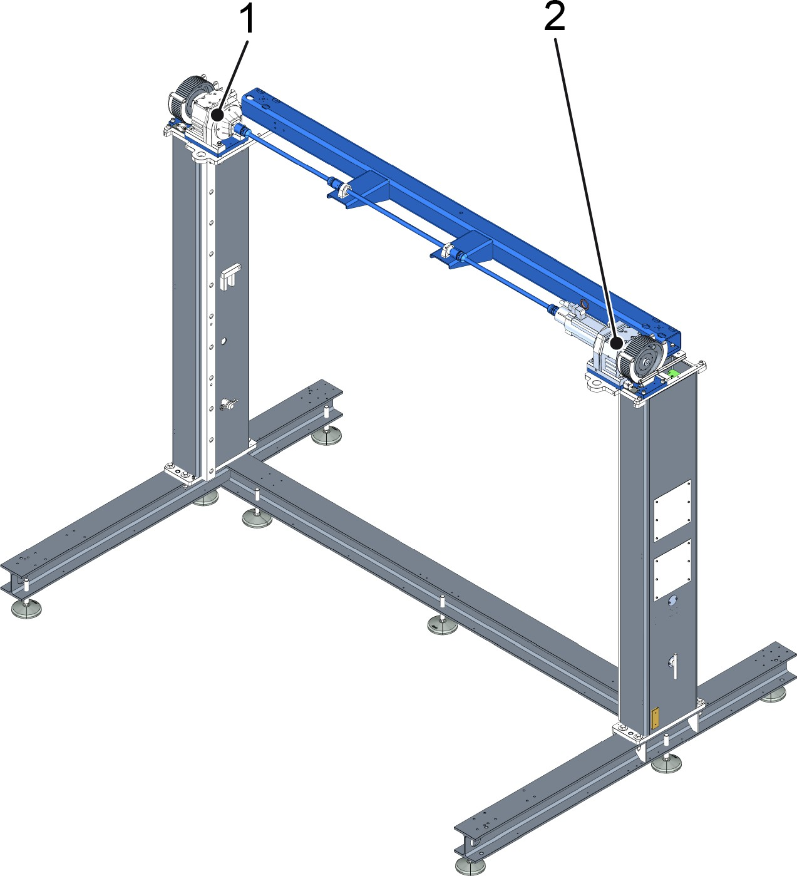

Figure 92: Lubrication points on the frame
- Spur gear unit
- Servo geared motor for moving the cross conveyor

Position | Assembly | Lubricant | Interval | Task
1 | Gearing mechanism | KHS GEAR FLUID 460 | Every three years / 21 000 hours | Change lubricant after specified interval
2 | Gearing mechanism | KHS GEAR FLUID 460 | Every three years / 21 000 hours | Change lubricant after specified interval

      - Lubrication point on the cross conveyor
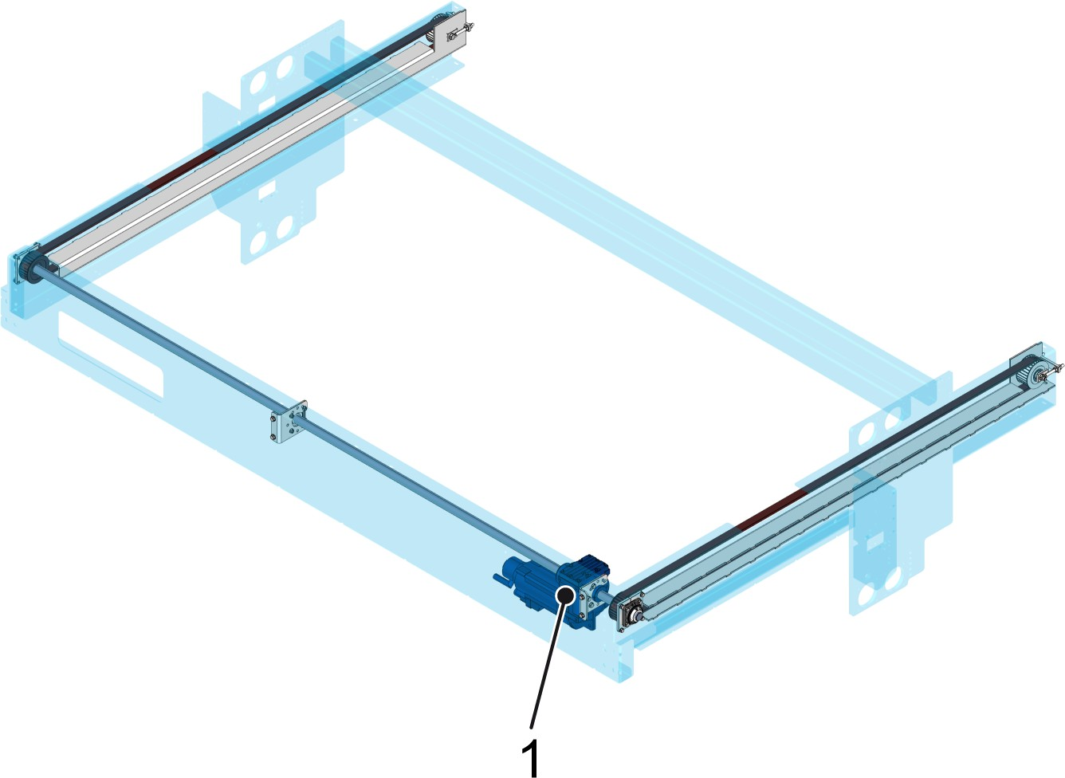

Figure 93: Lubrication point on the cross conveyor
1 Servo geared motor

Position | Assembly | Lubricant | Interval | Task
1 | Servo geared motor | KHS GEAR FLUID 460 | Every three years / 21 000 hours | Change lubricant after specified interval

      - Lubrication point on the lifting frame control

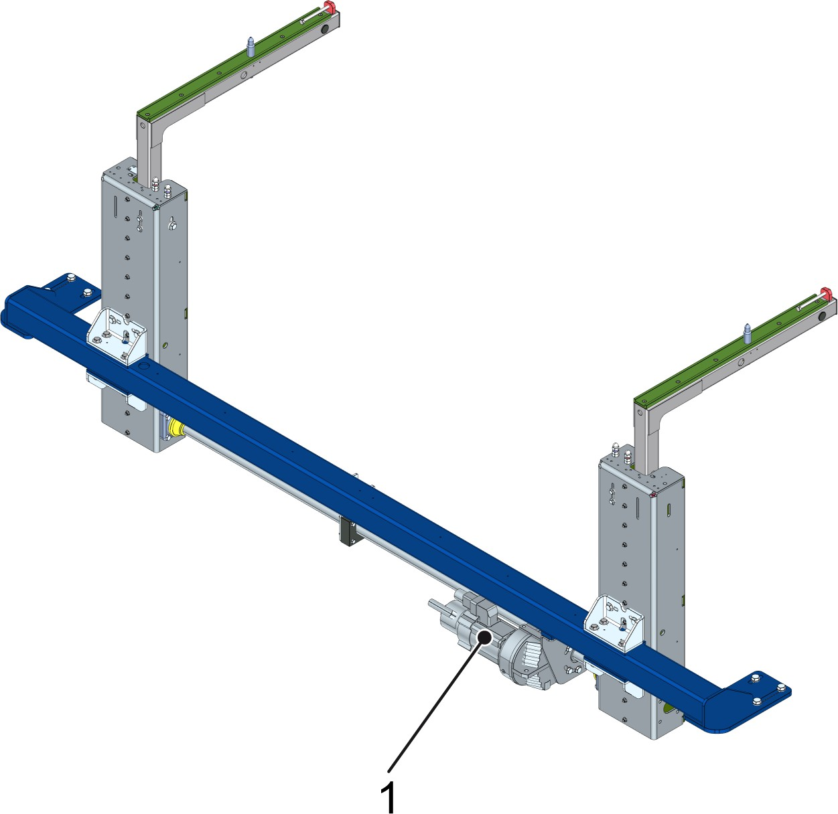

Figure 94: Lifting frame control lubrication point
1 Servo geared motor

Item | Assembly | Lubricant | Interval | Task
1 | Servo geared motor | KHS GEAR FLUID 460 | Every three years / 21 000 hours | Change lubricant after specified interval

      - Lubrication point on the pack conveyor
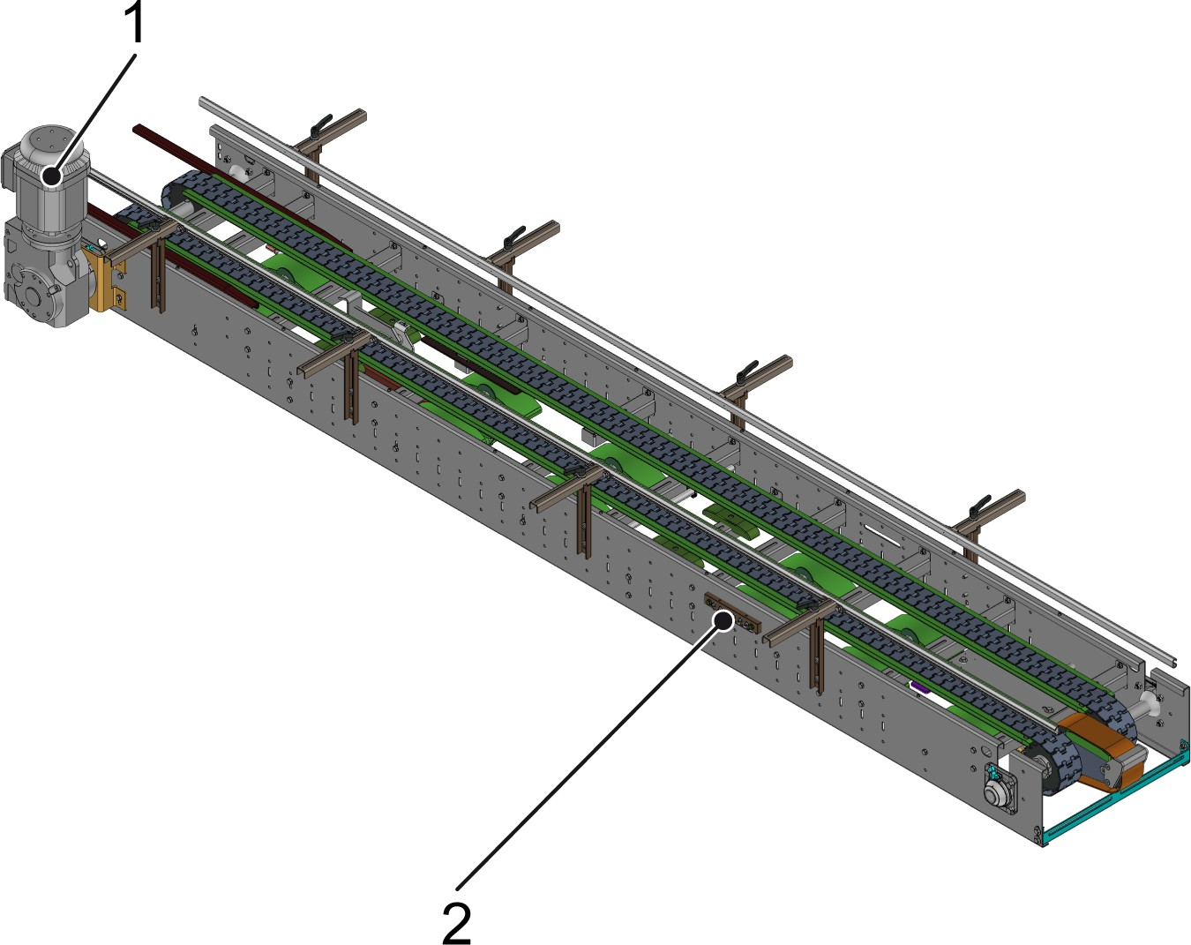

Figure 95: Lubrication point on the pack conveyor
- Geared motor for the pack conveyor
- Lubricating nipple on the lubricating strip of the pack conveyor

Item | Assembly | Lubricant | Interval | Task
1 | Geared motor | KHS GEAR FLUID 460 | Every three years / 21 000 hours | Change lubricant after specified interval
2 | Lubricating nipple | KHS MULTI GREASE 01 | Monthly/ every 500 h | Press 5 grams of grease into each lubricating nipple using the hand pump after specified interval  The bearings on the pack con‐ veyor, on the lifting frame con‐ trol and on the bottle table requiring lubrication are con‐ nected to the lubricating strip and lubricated via this strip

      - Lubrication point on the container table

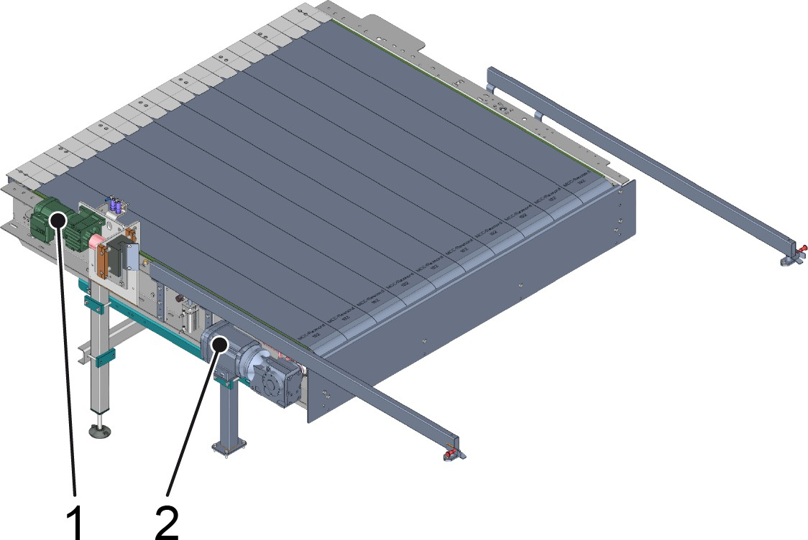

Figure 96: Lubrication schedule for container table
- Geared motor for the vibrating unit
- Geared motor for the container conveyor

Item | Assembly | Lubricant | Interval | Task
1 | Geared motor | KHS GEAR FLUID 460 | Every three years / 21 000 hours | Change lubricant after specified interval
2 | Geared motor | KHS GEAR FLUID 460 | Every three years / 21 000 hours | Change lubricant after specified interval

Supply of Spare Parts
Personnel:  Maintenance personnel
Prerequisites for disruption-free system operation: Reorder spare parts in plenty of time.
For information on determining spare parts, see the “ spare parts list ”.

KHS requires the following information when placing orders for spare parts:
- Type name
- Machine number
- Number of items

- Description of the spare parts
- Spare part order no.
- Any remarks pertaining to the spare parts, see “ spare parts list”.
For a preprinted form for a spare parts order, see the “spare parts list ”.

    - Servicing wear parts

Interval: According to information in the spare parts list
Place | Maintenance work | Personnel
Wear parts | Replace wear parts according to the speci‐ fied interval, see “Spare parts list” . | Maintenance personnel

    - Maintaining purchased parts

Interval: According to manufacturer instructions
Place | Maintenance work | Personnel
Purchased parts | Perform maintenance work according  to manufacturers' instructions: see “Pur‐ chased parts documentation”. | Maintenance personnel

  - Repairs
This chapter provides personnel with instructions on preventative actions for reducing wear and restoring the functionality of the machine.

Safety instructions
DANGER!
Restart after maintenance and repair work
There is a danger of fatal injury from non-approved restart.
This could lead to severe or even fatal injury.
- Ensure that all work is completely finished.
- Enure the operational safety of the machine.
- Restart the machine only after obtaining approval from the person in charge.
- Before restarting, ensure that there is no one in the vicinity of the machine. Give a startup signal.
WARNING!
Unauthorized machine startup
This could cause severe and even fatal injury.
- End production and stop the machine before car‐ rying out any work on the machine.
- Use your own padlock to secure the main switch against unauthorized startup.
- Secure and depressurize pneumatic components:
  - Switch off the control voltage for activating sole‐ noid valves.
  - Also, shut off the main air supply and depressu‐ rize the system.
  - Secure the air supply against unauthorized use with a padlock.

WARNING!
Accidental starting of the machine
Danger of being drawn in by moving machine parts! Danger of crushed limbs and lacerations! This could result in death or serious injury.
- Turn off the drive before carrying out any work on the machine.
- Turn off all necessary switches
- Use your own padlock to secure the main switch
at the electrical switch cabinet against unauthorized startup.
Each operator must secure the machine against inadvertent startup with his/her own padlock. This is particularly when several operators work on the machine.
- As far as possible, all work must be performed with the machine secured and deenergized.
WARNING!
Pressurized system
Danger of injury from flying components and flowing media when opening pressurized components, tanks, and pipes.
This could cause severe and even fatal injury. – Before working on the system, depressurize
(relieve the pressure) and drain the system and
components.
WARNING!
Environmental pollution resulting from improper dis‐ posal
There is a risk of polluting the environment if operating materials such as lubricants and detergents are not disposed of properly.
- Follow the instructions in the leaflets enclosed with the operating materials.
- Collect used operating materials in suitable con‐ tainers marked in accordance with regulations.
- Dispose of contaminated cleaning utensils in suit‐ able containers marked in accordance with regula‐ tions.
- Observe local disposal regulations.

NOTICE!
Non-qualified personnel
May result in damage to the machine or the sur‐ rounding area.
– Only qualified personnel should perform work on the machine.
NOTICE!
Use original parts from KHS
Original parts not supplied from KHS are not tested and approved. KHS will not be held liable for any damage resulting from the use of non-original parts.
– Only use original parts from KHS
NOTICE!
Improper cleaning of electrical equipment Risk of machine damage
- Never spray electrical equipment, switch or oper‐ ator panels, switch and control cabinets etc. with water.
- Never spray light barriers, inductive proximity switches, or sensors and ultrasonic sensors with water.
NOTICE!
Damage to components
Failure to replace wear parts at the times specified in the spare parts list leads to machine damage.
Replace wear parts at the times specified in the spare parts list.

    - Preparation
Personnel:  Maintenance personnel Prerequisite:

- Production on the machine has ended, see section “Ending production” .
Check the secured area for residues of processing materials. If necessary, enter the secured area and manually remove any residual processing materials.
  - The machine has been prepared for setup.

Setting reflective light barriers Layout
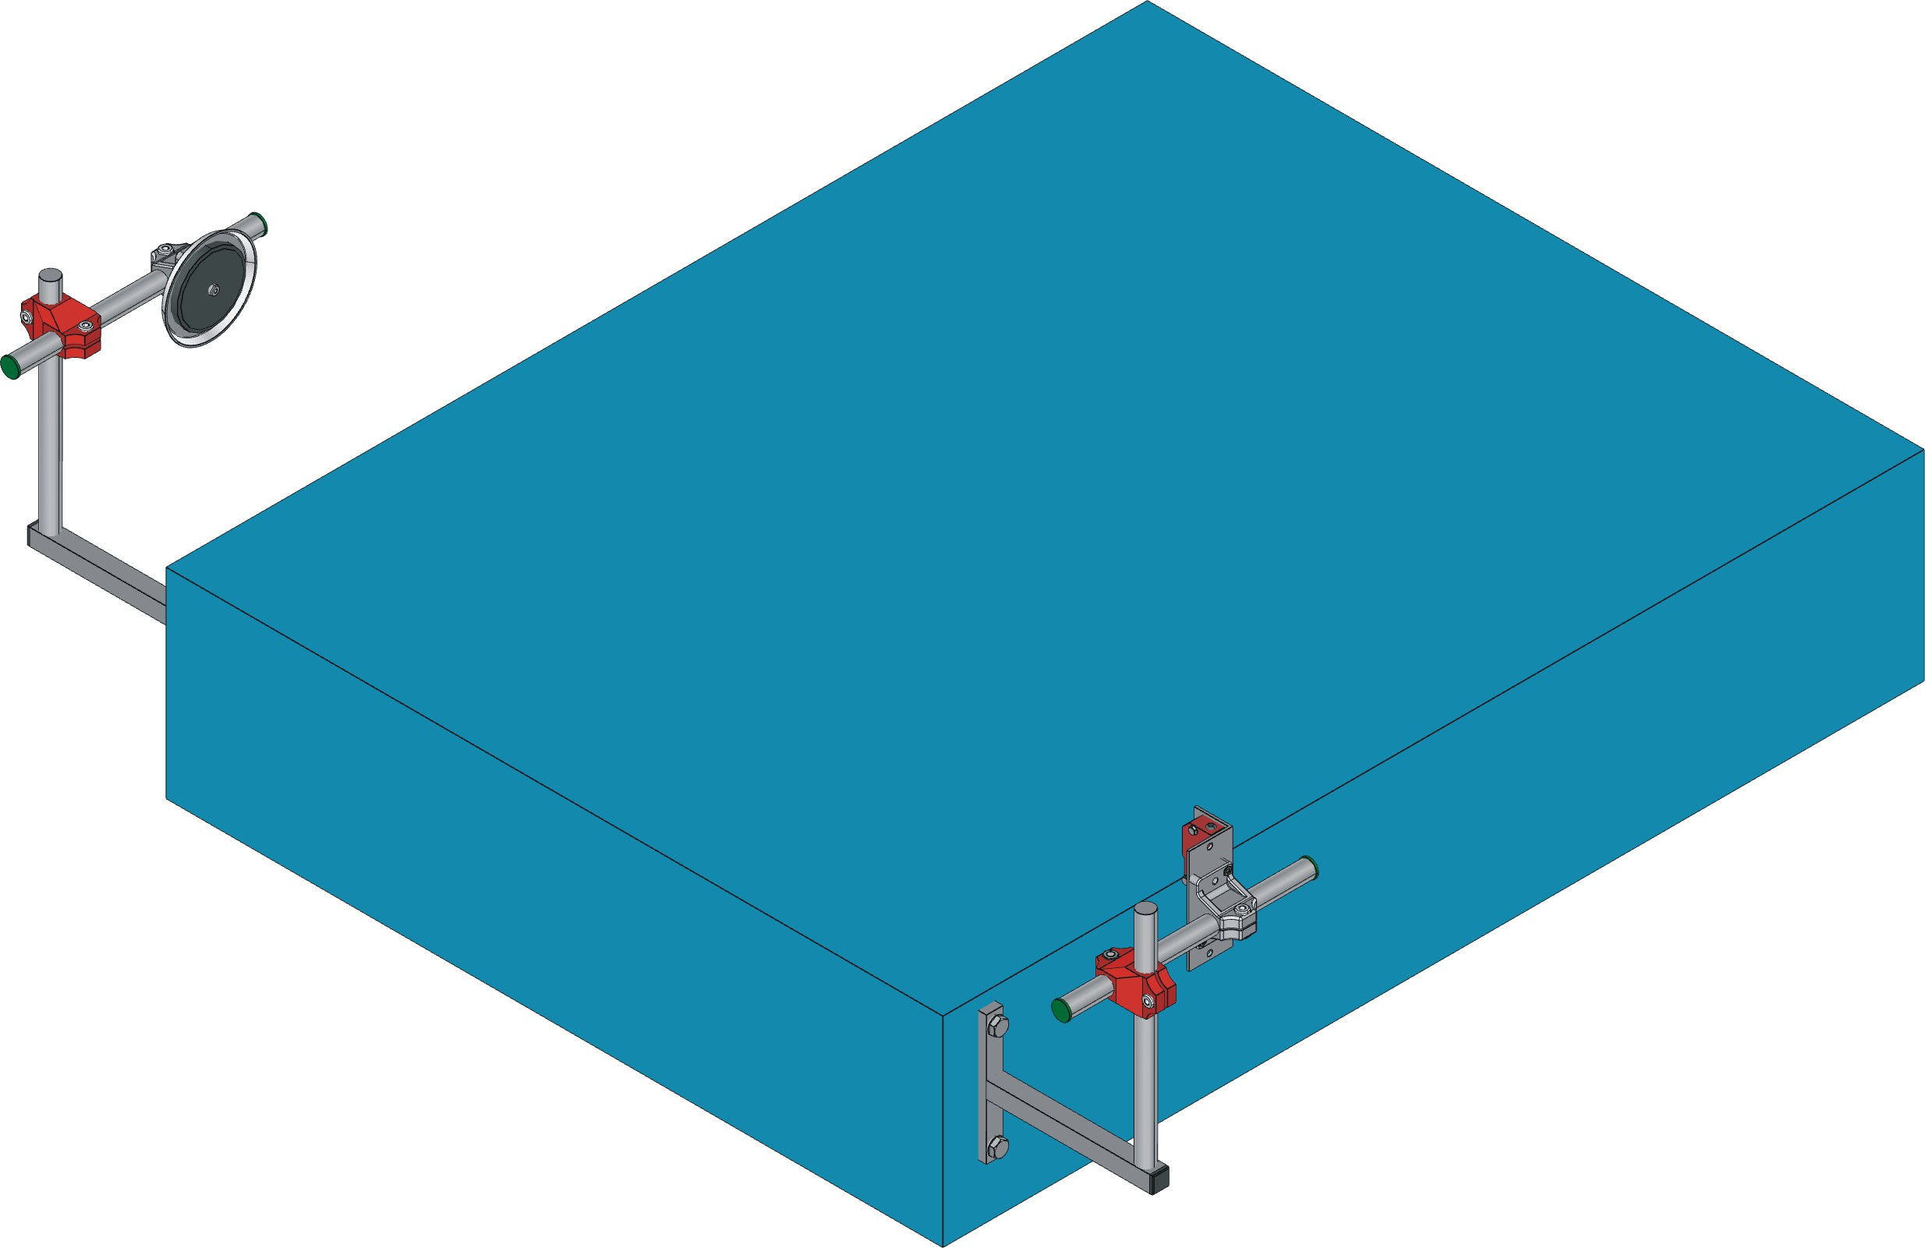
1 2 3

Figure 97: Reflective light barrier
- Reflector
- Conveyor segment
- Light barrier

Personnel:  Maintenance personnel Prerequisite:
Light barrier and reflector are no longer aligned.
- Loosen brackets.
- Align the light barrier and reflector.
- Fasten brackets.

Light barrier
Get the setting parameters from the “Purchased parts documentation”.

This page is left blank for editorial reasons.

